# Executive Summary

## Kickstarter is a crowdfunding platform for soliciting contributions from the public, thereby circumventing traditional avenues of investment. Campaigns are launched with a funding goal and a funding deadline and promises rewards based on the amount pledged by a backer. The purpose of this report is to analyze past projects to uncover insights on factors that are associated with higher rates of success.

# Data

## A dataset of 4,114 past kickstarter projects was analyzed for this project. Parameters included goal, amount pledged, state (aka outcome), category/subcategory, location and currency as well as dates of launch and deadline.

## The data was cleaned by separating category and sub category to allow review effect of each and dates were converted from Unix timestamps into standard form.

# Methods

## The data was first moved into three different pivot charts to view outcome by category, subcategory and date. Appropriate charts were produced for each set including bar, stacked bar, radar, and line. (Tabs 2-4)

## Additional tables were added to examine percentage of success, failure and cancellation to account for difference in data counts. (Tabs 5-6)

# Analysis

## The below chart demonstrates that certain categories were overrepresented within the dataset, theater in particular. (fig. a)

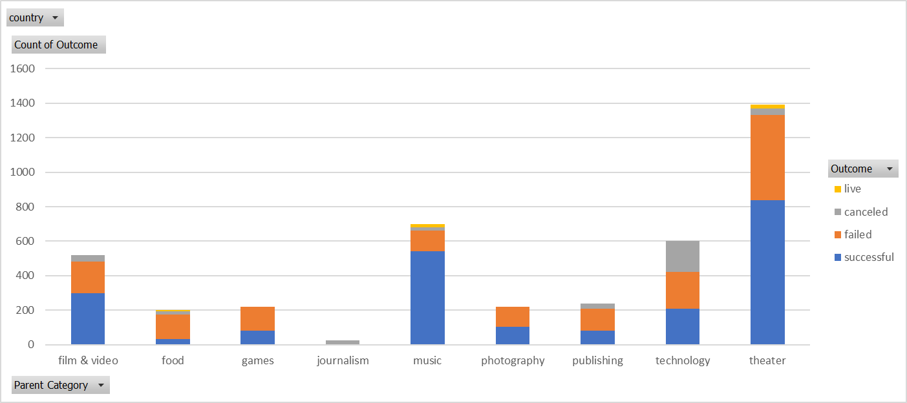

*Fig. a*

## Further analysis by sub category reveals that over 80% of subcategories in the provided dataset were either 100% or 0% successful. (fig. b)

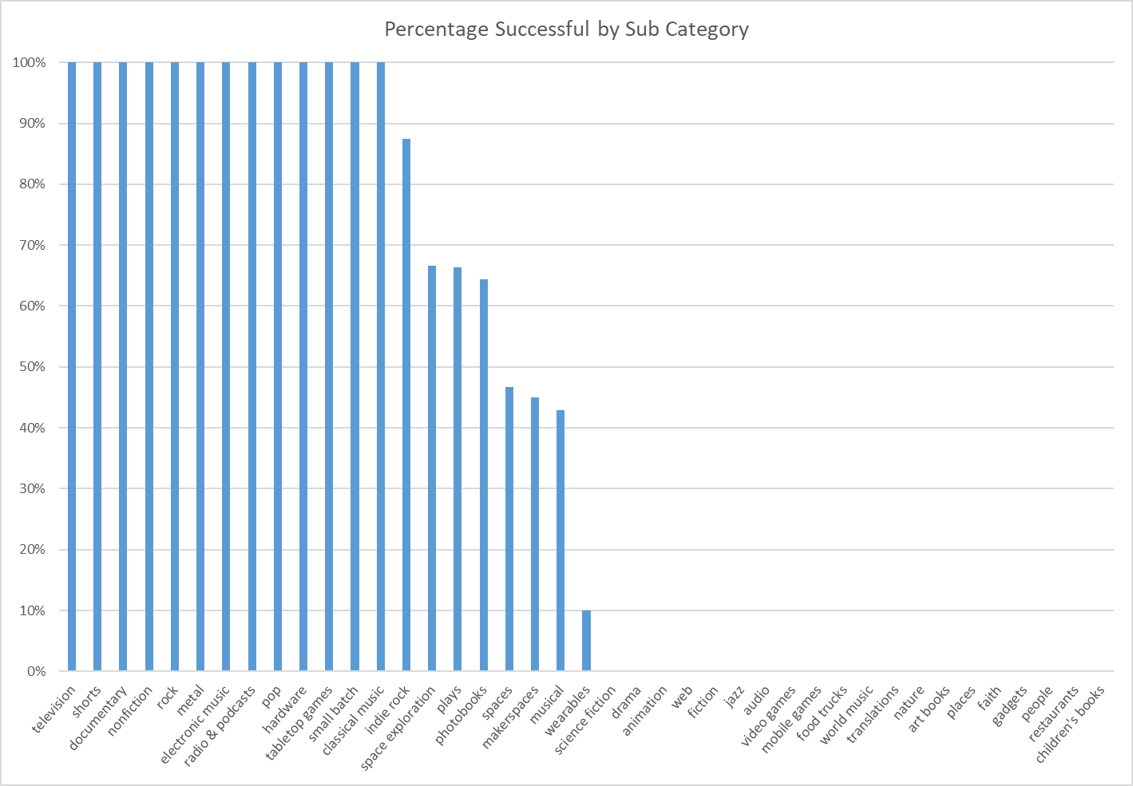

*Fig. b*

## Outcome by date illustrates a trend down in successful campaigns toward the end of the calendar year within the dataset. (fig. c & d)

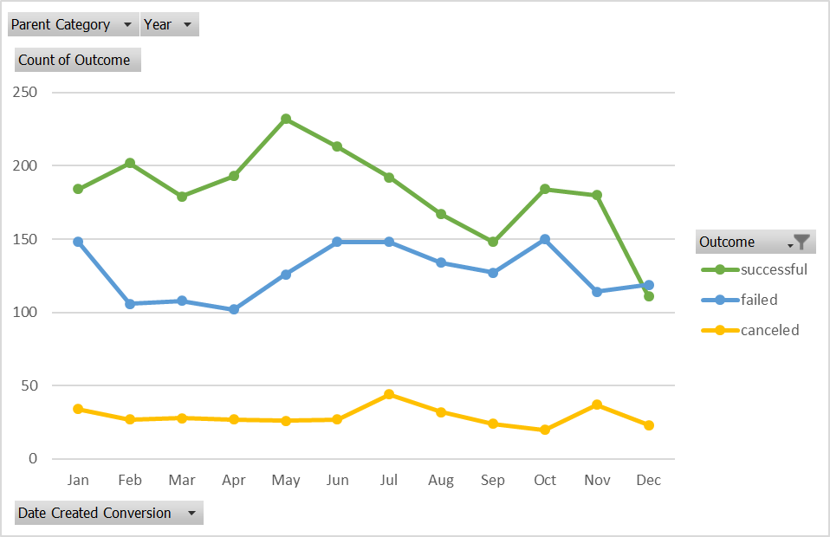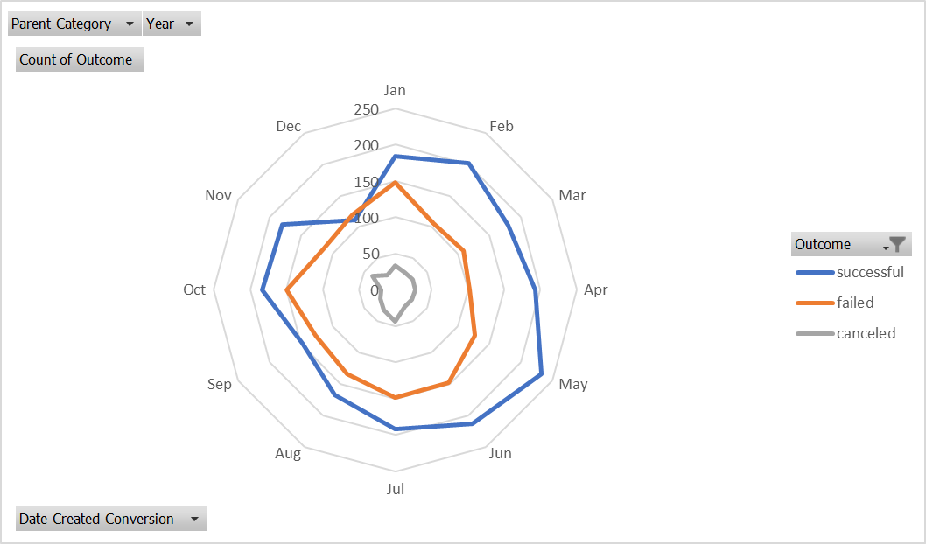

*Fig. d*

*Fig. c*

## Comparing percentage of success by category reveals that within the analyzed dataset campaigns labeled music, theater and film & video had the highest rates of success. (fig. e)

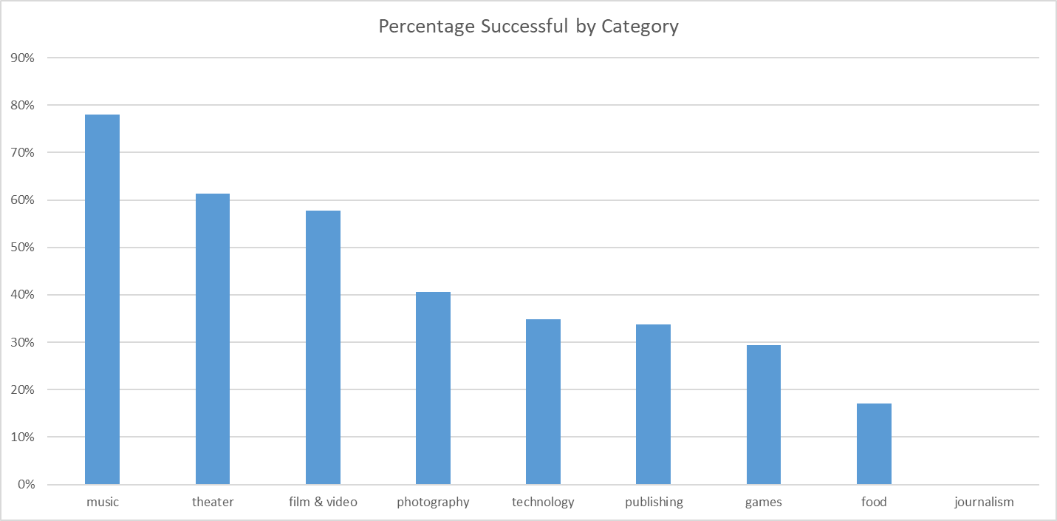

*Fig. e*

## A line chart comparing rates of success by funding goal produced the below line chart. As illustrated below, campaigns within the dataset with lower funding goals were more likely to be successful than those with higher funding goals. (fig. f)

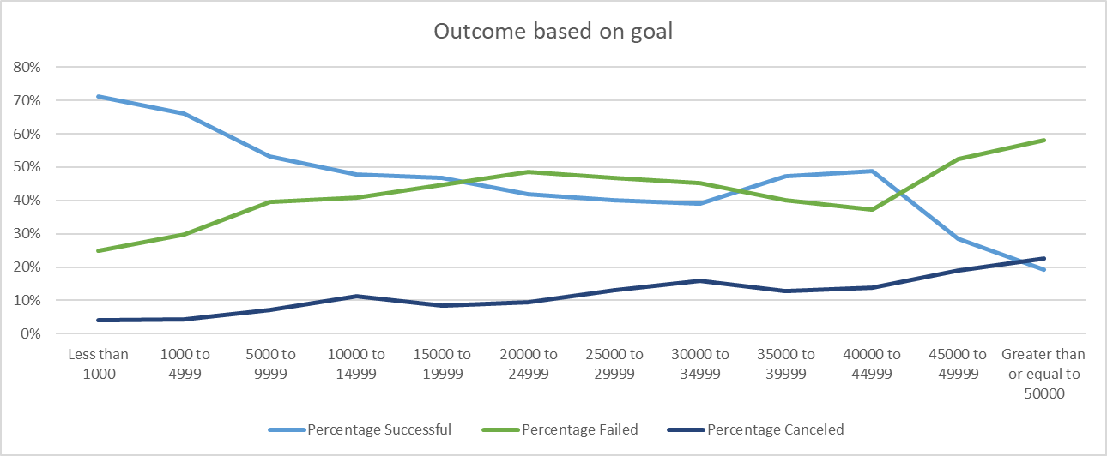

*Fig. f*

## The below chart illustrates that campaigns in this dataset with a staff pick or spotlight indicator were more likely to be successful. With slightly over 50% campaigns successful overall, <85% campaigns successful when a staff pick and 100% campaigns successful when spotlighted, some kind of promotion is a strongly shown to increase rates of success. (Fig g)

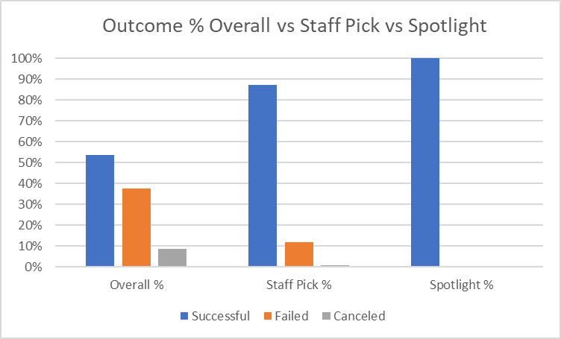

*Fig. g*

# Results

## The limitations of this dataset notwithstanding, several indicators of success were identified. Further analysis with larger datasets of past campaigns would be beneficial to achieving truly actionable insights. It would be advantageous to include the kinds of award offered to backers; combined with average contribution it could show what kinds of rewards are attracting the high dollar contributions more often.

# Conclusions

## The results of this analysis suggest several factors to consider when preparing a new campaign for kickstarter. The following bullet points were associated with more frequently successful campaigns.

* Campaigns starting in late Winter or Early Spring
* Lower funding threshold
* Categories associated with entertainment (Music, theater or film & video)
* Campaigns with a staff pick or spotlight